EXPLAINABLE MULTI-CLASS CHEST X-RAY DISEASE CLASSIFICATION USING CONVNEXT AND REPVIT

INTRODUCTION
Chest X-rays are widely used to diagnose respiratory diseases such as pneumonia and COVID-19. However, manual interpretation of chest X-rays is time-consuming and depends on the availability and experience of expert radiologists.
The Explainable Multi-Class Chest X-Ray Disease Classification project aims to classify a chest X-ray image into one of four classes: Normal, Viral Pneumonia, COVID-19, and Lung Opacity, and to provide a visual explanation of each prediction.
The proposed framework first uses a U-Net to segment the lung region from the X-ray image. The segmented image is then intended to be given to two deep learning models, ConvNeXt and RepViT, to extract complementary features. These features are to be fused and classified by a dense classifier, and Grad-CAM is to be used to highlight the image regions that influenced the prediction. The project is implemented in Python using PyTorch and the COVID-19 Radiography Database.
The project is currently under development. The dataset preparation and the U-Net lung segmentation stage have been completed, and the U-Net achieved a Dice score of 98.04% on the test images. The ConvNeXt and RepViT classification, Grad-CAM explanation, and final performance evaluation are the remaining work.

PROBLEM STATEMENT
Diagnosing respiratory diseases from chest X-rays requires expert radiologists and can take considerable time. Different diseases, such as COVID-19, viral pneumonia, and other lung opacities, can look similar on an X-ray, which makes manual diagnosis difficult. In addition, many deep learning models provide only a predicted label and do not show why the prediction was made.
Therefore, the project aims to develop an explainable deep learning system that segments the lung region, classifies chest X-rays into multiple disease classes, and provides visual explanations for its predictions.

OBJECTIVES
- To segment the lung region from chest X-ray images using U-Net.
- To extract complementary deep features using ConvNeXt and RepViT.
- To classify chest X-rays into Normal, Viral Pneumonia, COVID-19, and Lung Opacity.
- To provide visual explanations of predictions using Grad-CAM.
- To evaluate the system using Accuracy, Precision, Recall, F1-Score, ROC-AUC, 5-fold cross-validation, and an independent test set.

EXISTING SYSTEM
The existing systems studied for this project use hybrid Vision Transformer (ViT) and CNN models to classify chest X-ray images. For example, MSAF-Net (ViT with EfficientNetB0) and DAR-Net (ViT with ResNet50) combine CNN and Transformer features with attention-based fusion to classify COVID-19, lung opacity, normal, and pneumonia images.
Other existing approaches use CNN models such as InceptionV3 with Integrated Gradients, or ensembles of DenseNet, EfficientNet, and VGG16, mainly for binary Normal versus Pneumonia classification.

DRAWBACKS OF THE EXISTING SYSTEM
- No explicit lung-region segmentation is performed.
- High computational complexity.
- Complex hybrid architecture.
- Requires extensive preprocessing.
- Several approaches are limited to binary classification (Normal versus Pneumonia).

PROPOSED SYSTEM
The proposed system uses U-Net to segment the lung region from the chest X-ray image. The segmented image is to be processed by ConvNeXt and RepViT to extract complementary deep features. The extracted features are to be fused and classified into Normal, Viral Pneumonia, COVID-19, and Lung Opacity using a dense classifier.
Grad-CAM is intended to generate heatmaps that explain the model's predictions. The system is being developed incrementally. The dataset preparation and U-Net lung segmentation have been completed, while the feature extraction, classification, explainability, and evaluation stages are part of the ongoing work.

ADVANTAGES OF THE PROPOSED SYSTEM
- Supports multi-class disease classification.
- Uses U-Net for accurate lung segmentation (test Dice score of 98.04% achieved so far).
- Combines ConvNeXt and RepViT for better feature extraction.
- Provides explainable predictions using Grad-CAM.
The advantages related to ConvNeXt, RepViT, and Grad-CAM are expected benefits of the design and will be confirmed after those stages are implemented and evaluated.

SYSTEM REQUIREMENTS

Hardware Requirements
- A computer with an internet connection to access the cloud notebook environment.
- GPU: NVIDIA Tesla T4 (CUDA 12.8), as used in the Kaggle notebook for training the U-Net.
- Sufficient storage for the dataset, segmented images, and saved model checkpoints.

Software Requirements
- Environment: Kaggle Notebook
- Programming Language: Python
- Deep Learning Framework: PyTorch and Torchvision
- Data Handling: NumPy, Pandas, and Pillow
- Data Splitting: scikit-learn
- Visualization: Matplotlib
- Dataset: COVID-19 Radiography Database
- Planned for later stages: timm (ConvNeXt-Tiny and RepViT-M1 models), OpenCV (Grad-CAM overlays), and scikit-learn metrics (evaluation)
The above list describes the project environment and intended technology stack. Components planned for later stages should not be considered completed.

SYSTEM DESIGN
The diagrams in this section describe the complete planned system. At the current stage, the dataset, preprocessing, and segmentation parts of the design have been implemented.

System Architecture
The proposed system consists of preprocessing, lung segmentation, two feature-extraction branches, a feature fusion layer, a dense classifier, and an explainability module. The input chest X-ray is resized and normalized, and the U-Net generates a lung mask. The segmented lung image is intended to be given to the ConvNeXt and RepViT branches in parallel, and their features are fused before classification. Grad-CAM is intended to produce a heatmap along with the predicted disease class.
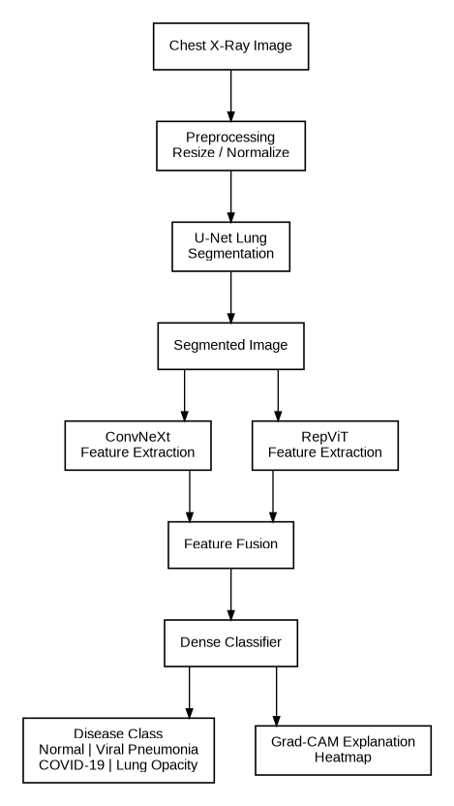
Figure 1: System Architecture

System Flowchart
The planned workflow begins with the collection of the chest X-ray dataset. The dataset and its classes are analysed, and the images are resized to 224 × 224 and normalized. The lungs are segmented using U-Net, features are extracted using ConvNeXt and RepViT, and the features are fused and passed to the dense classifier. The predicted class is then displayed together with the Grad-CAM explanation.
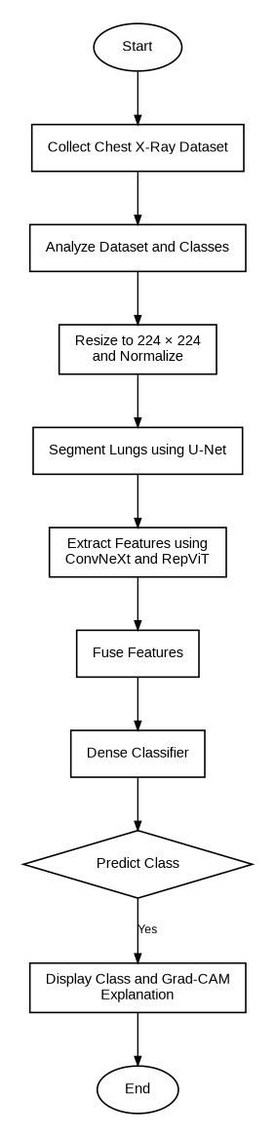
Figure 2: System Flowchart

Behavioural Design
The user submits a chest X-ray image. The system is designed to load and preprocess the image, generate the lung segmentation mask, and run ConvNeXt and RepViT on the segmented image. The extracted features are fused and used to classify the disease. A Grad-CAM heatmap is then generated, and the predicted class and explanation are displayed to the user.
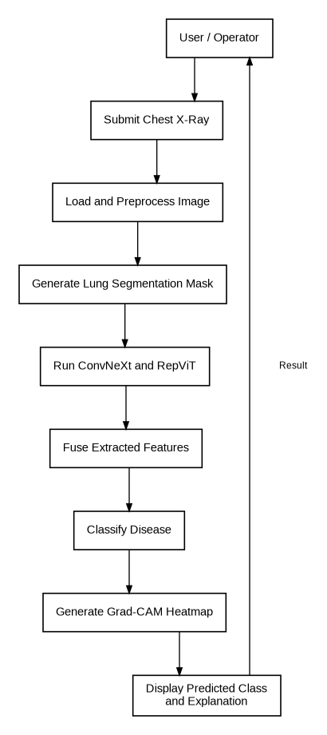
Figure 3: Behavioural Design

Data Flow Diagram
In the level 0 data flow diagram, the user or researcher provides a chest X-ray image, and the chest X-ray dataset provides labelled X-ray data to the Chest X-Ray Disease Classification System. The system is designed to return the predicted disease class and the Grad-CAM heatmap, which are displayed to the user.
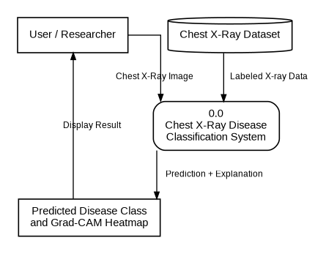
Figure 4: Data Flow Diagram (Level 0)

METHODOLOGY
The project follows a step-by-step development approach.

Dataset Preparation
The COVID-19 Radiography Database is used. It contains chest X-ray images and their lung masks for four classes: COVID-19, Normal, Viral Pneumonia, and Lung Opacity. A balanced dataset is prepared by randomly selecting the same number of images from each class. This step has been completed.

Preprocessing
The images are converted to grayscale and resized to 224 × 224, and the masks are resized using nearest-neighbour interpolation and converted to binary masks. This step has been completed for segmentation. Normalization using ImageNet mean and standard deviation values is planned for the classification stage.

Lung Segmentation
A U-Net is trained to predict the lung mask. The predicted mask is applied to the X-ray image to remove irrelevant background regions and keep the lung area. Segmentation performance is measured using the Dice score. This step has been completed.

Feature Extraction and Fusion
The segmented image is to be given to ConvNeXt-Tiny and RepViT-M1, and the two feature vectors are to be fused. This step is planned.

Classification
A dense classifier is planned to predict one of the four classes: COVID-19, Normal, Viral Pneumonia, or Lung Opacity.

Explainability
Grad-CAM is planned to be applied to the classification model to highlight the lung regions that contribute to the predicted class.

Performance Evaluation
The classification model is planned to be evaluated using Accuracy, Precision, Recall, F1-Score, and ROC-AUC, using 5-fold cross-validation and an independent test set.
These steps describe the intended workflow. Dataset preparation, preprocessing, and lung segmentation have been completed, and the remaining stages still require development and testing.

WORKFLOW
The proposed workflow is:
- The user provides a chest X-ray image.
- The image is resized and normalized.
- U-Net generates the lung mask and the lung region is segmented.
- ConvNeXt and RepViT extract features from the segmented image.
- The extracted features are fused.
- The dense classifier predicts the disease class.
- Grad-CAM generates a heatmap explaining the prediction.
- The predicted class and the heatmap are displayed.

IMPLEMENTATION

Dataset Preparation
The original database contains 3,616 COVID-19, 10,192 Normal, 1,345 Viral Pneumonia, and 6,012 Lung Opacity images, and every image has a matching lung mask. To avoid class imbalance, 1,345 images (the size of the smallest class) were randomly selected from each class with a fixed random seed, giving a balanced dataset of 5,380 images.
From this dataset, 15% (807 images) was held out as an independent test set using a stratified split. The remaining 4,573 images were split into 3,658 training images and 915 validation images. A check confirmed that no image appears in both the test set and the development data.
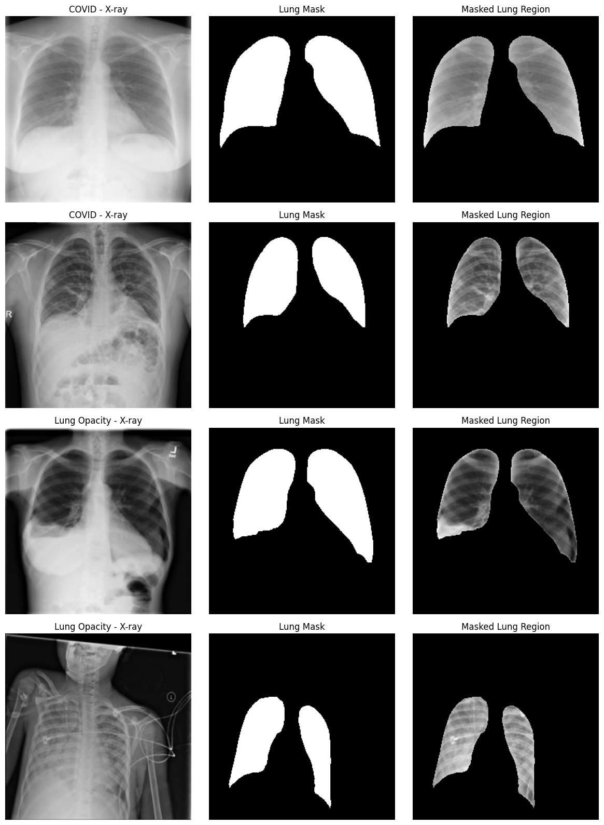
Figure 5: Sample X-rays, lung masks, and masked lung regions

U-Net-Based Lung Segmentation
The U-Net has four encoder levels (32, 64, 128, and 256 filters), a 512-filter bottleneck, and a matching decoder with skip connections, giving 7,763,041 parameters. The images are resized to 224 × 224, and the masks are converted to binary masks.
The U-Net was trained for 15 epochs with a batch size of 16 using the AdamW optimizer (learning rate 1e-4) and a combined Binary Cross-Entropy and Dice loss. The checkpoint with the best validation Dice score was saved. The predicted mask is multiplied with the X-ray image to generate the segmented lung image, and segmented images were generated for the training, validation, and test sets.
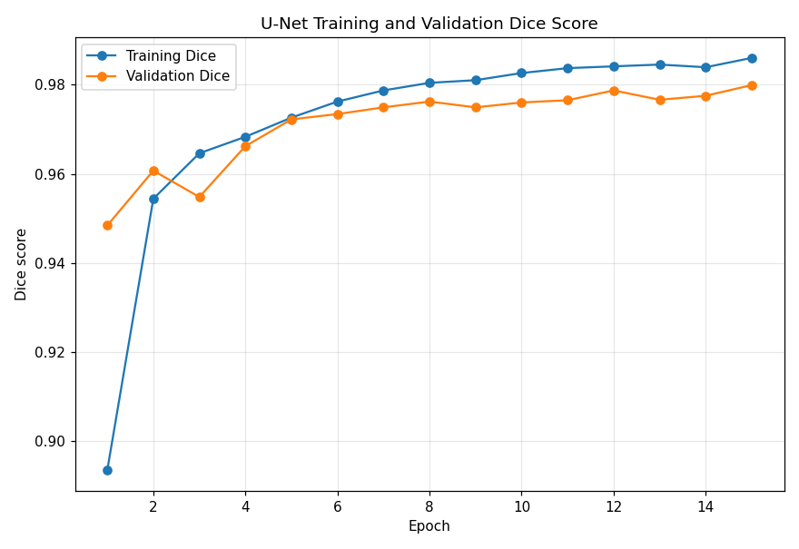
Figure 6: U-Net Training and Validation Dice Score

Segmentation Results
The U-Net reached a best validation Dice score of 97.99% (epoch 15). On the 807 independent test images, it achieved a Dice score of 98.04%, which is close to the validation score and shows that the segmentation generalizes to unseen images.
Measure | Value | Images
Best validation Dice | 97.99% | 915
Test Dice | 98.04% | 807
Model parameters | 7,763,041 | -
Table 2: U-Net Segmentation Results
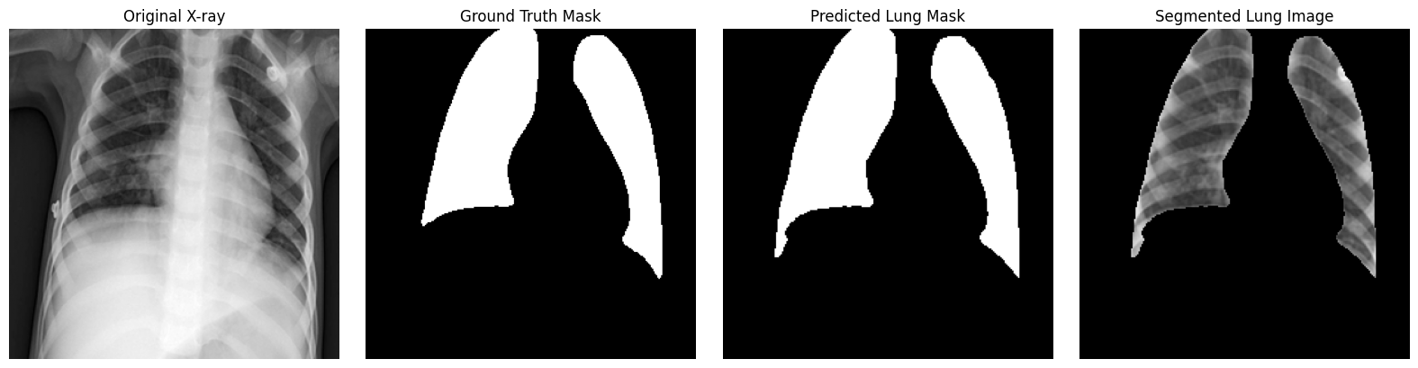
Figure 7: Original X-ray, ground-truth mask, predicted mask, and segmented lung image

Current Status
The dataset has been prepared and split, and the U-Net lung segmentation has been implemented, trained, and evaluated. The segmented lung images are ready to be used as input to the classification stage. The ConvNeXt and RepViT classification, Grad-CAM explanation, and final evaluation are still to be completed.

Future Work
- Implement ConvNeXt-Tiny and RepViT-M1 feature extraction on the segmented images.
- Fuse the extracted features and train the dense classifier for the four classes.
- Apply Grad-CAM to generate heatmaps that explain the predictions.
- Evaluate the classifier using Accuracy, Precision, Recall, F1-Score, and ROC-AUC.
- Perform 5-fold cross-validation and evaluate the model on the independent test set.
- Analyse the confusion matrix and class-wise performance.

CONCLUSION
The Explainable Multi-Class Chest X-Ray Disease Classification project aims to classify chest X-rays into Normal, Viral Pneumonia, COVID-19, and Lung Opacity using lung segmentation, ConvNeXt and RepViT feature fusion, and Grad-CAM explanations. The dataset preparation and the U-Net lung segmentation stage have been completed, and the U-Net achieved a Dice score of 98.04% on the test images.
Further development and testing are required to implement the classification, explainability, and evaluation stages and to complete the proposed system.

